Seven Circuits Spring Conference Schedule
April 20-22, 2025
Dr. A. Andrew Das, Professor Department of Religious Studies at the Elmhurst Univerity in Elhurst Illinois.
Topic: Paul, the Mosaic Law, and Remarriage, with a Little Thessalonian Detour.

Monday April 20 (All sessions will be held at Long’s Peak Lodge, Keyhole Meeting Room)
3:00-4:00 PM Room Check In – Get your key card from Nierman in Longs Peak Lodge Keyhole Room
4:00 – 5:15 PM 75 minute Session with Dr. Das – Meeting Room
5:30- 6:30 PM Dinner (Aspen Dining Room for all meals)
6:45-7:45 PM 60 Minute Session with Dr. Das
8:00- 10:00 PM Gemutlichkeit Social Time (BYOB) – Meeting Room
Tuesday April 21
7:00-8:00 AM Breakfast – Aspen Dining Room
8:15-8:30 AM Morning Devotion – Meeting Room
8:30-9:25 AM 55 Minute Session with Dr. Das
9:25-9:35 AM 10 Minute Break
9:35-10:30 AM 55 Minute Session with Dr. Das
10:30-10:40 AM 10 Minute Break
10:40-11:35 AM 55 Minute Session with Dr. Das
11:35-11:45 AM 10 Minute Break
11:45-12:15 AM 30 Minute Session with Dr. Das
12:20 PM Lunch in Aspen Dining Room
After Lunch Free time
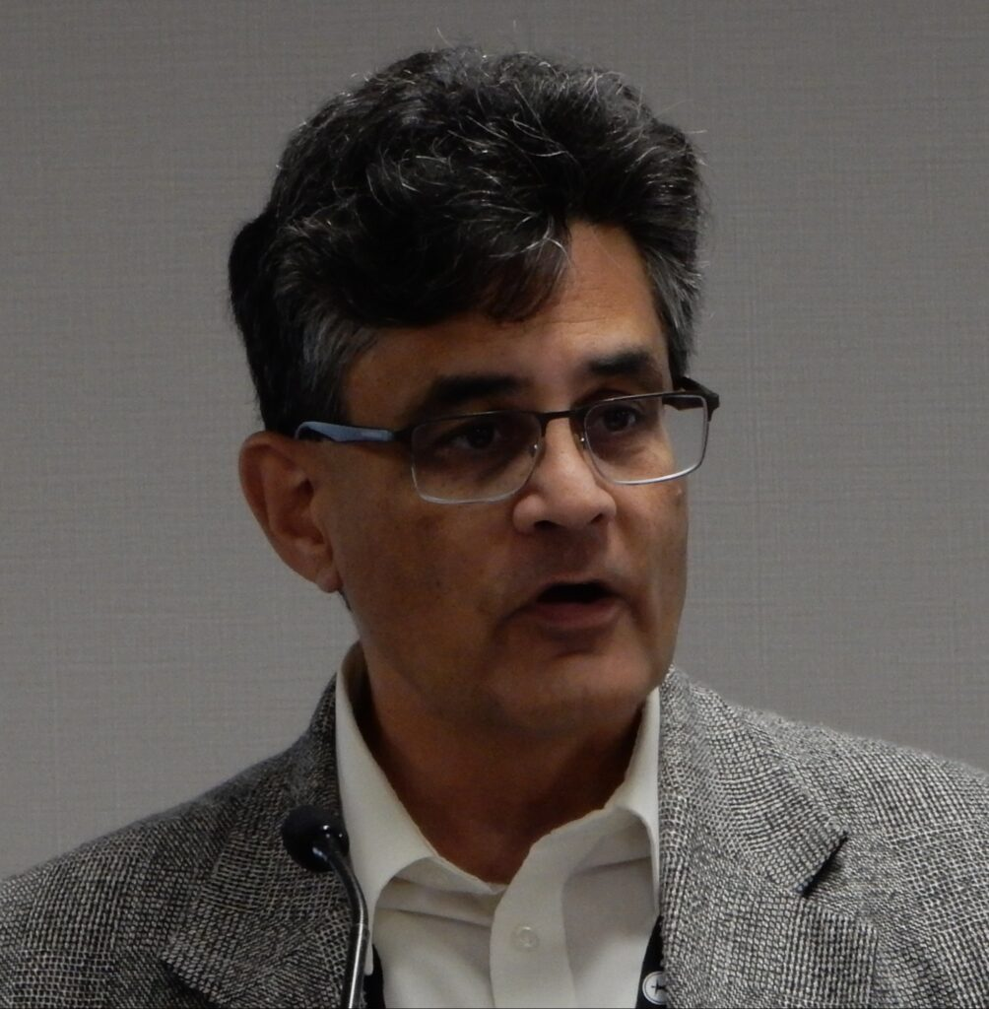
Dinner Served in Aspen Dining Room beginning at 5:00 pm
7:30 – 9:30 PM Gemutlichkeit Social Time (BYOB)
Wednesday April 22
7:00-8:00 AM Breakfast Aspen Dining Room
8:15-8:30 AM Morning Devotion
8:30-9:25 AM 55 Minute Session with Dr. Das – Longs Peak Lodge
9:25-9:35 AM 10 Minute Break
9:35-10:30 AM 55 Minute Session with Dr. Das
10:30-11:00 AM 30 Minute Break for room check out
11:00-11:45 AM 45 Minute Session with Dr. Das
11:45-11:50 AM 5 Minute Break
11:50-12:05 AM Closing Devotion

Andrew Das is the Donald W. and Betty J. Buik Chair at Elmhurst College. Dr. Das authored Galatians (Concordia Academic, 2014) Solving the Romans Debate (Fortress, 2007); Paul and the Jews (Hendrickson, 2003); Paul, the Law, and the Covenant (Hendrickson, 2001); and Baptized into God’s Family (Northwestern, 1991; 2d ed., 2008). He coedited The Forgotten God (Westminster John Knox, 2002). His Grand Thematic Narratives of Galatians is forthcoming from Fortress.

He received his M.Div. from Concordia Theological Seminary and did his graduate work at Yale University, Duke University, and Union Theological Seminary in Virginia. He served as a pastor at Trinity Lutheran Church (LCMS) in Lombard, Ill., from 2000–2002 and assisted as a pastor at St. John’s Lutheran in Lombard from 2002–2004.

