SHARING CHRIST. SERVING PEOPLE
Trinity Lutheran School
Greeley, Colorado

Full-time K-8 Principal with limited classroom assignments
Trinity Lutheran School houses approximately 100 students with a dedicated staff providing a Christ centered learning environment. Our facility is home to our K-8 school, our preschool/childcare center, school and church administration offices and our very own, Trinity Quilters. We are Located at 3000 35th Ave, adjacent to Trinity Lutheran Church, in popular Northern Colorado.
We have been Trinity Lutheran Church’s primary mission serving the Greeley community for over 75 years.
Imagine the chance to enjoy morning coffee gazing at the mountains; better yet, Greeley is conveniently located just one hour away from all the mountain activities. In addition, one hour from the culture and sporting activities in Denver and the wide open spaces and Western history of Cheyenne, WY. Greeley is a growing community with many cultural and social amenities but has not lost its western flavor, continuing to be the home of the largest 4th of July Rodeo, the Greeley Stampede.
Please visit our website to learn more about us www.tlgreeley.org
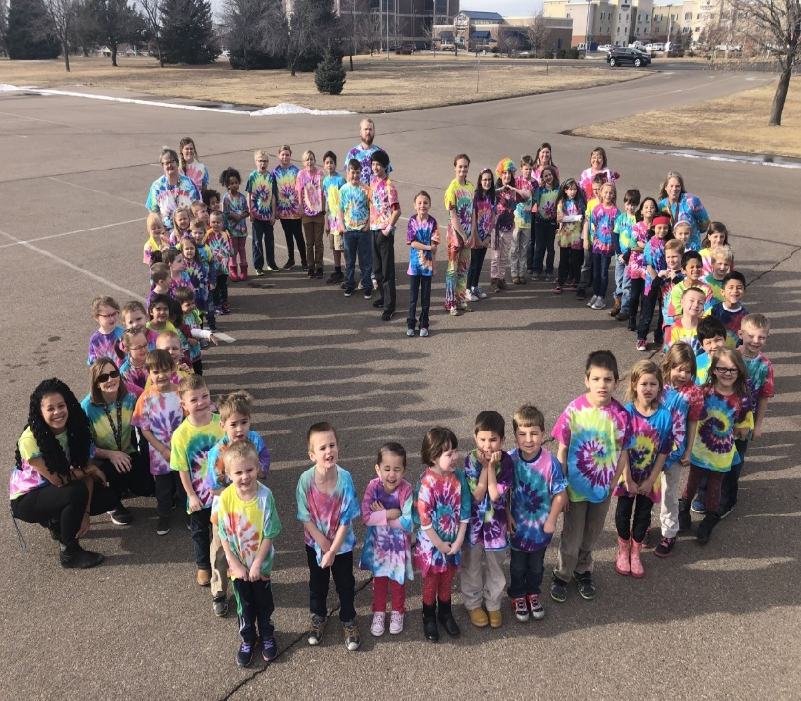
If God is leading you to consider this ministry opportunity, contact Pam Clavir at pamela.clavir@gmail.com.

