Job Opening: Principal of St. John’s in Denver

About St. John’s

St. John’s Lutheran School is a vibrant, joyful, Christian School located in urban Denver that is looking for a K-8 Principal. The School and Early Learning Center currently has over 300 students. The Church and School are considered one in ministry and partner together to connect people to Jesus. The city of Denver provides an amazing mission opportunity as many are living without the grace and truth of Jesus in their lives.
Our campus is located right across the street from Wash Park. Here is a description of Wash Park from Wikipedia: “Washington Park is a neighborhood and public urban park in Denver, Colorado. The Washington Park located in Denver, Colorado, United States is a blend of historic and contemporary styles of architecture. Its historic buildings, lakes, tennis courts, lawns, large flower gardens, and recreation center provide various experiences for visitors….The park is very popular both as a tourist destination and among Denver locals, with some comparing it to New York City's Central Park.^{[2]} Apart from activities like jogging, walking or biking, the park serves as a center for social activities and encourages community involvement. Due to its welcoming appearance and unique characteristics, the Washington Park was designated as one of the “Great Public Spaces in America” by the American Planning Association in the year 2012.”^{[3]}

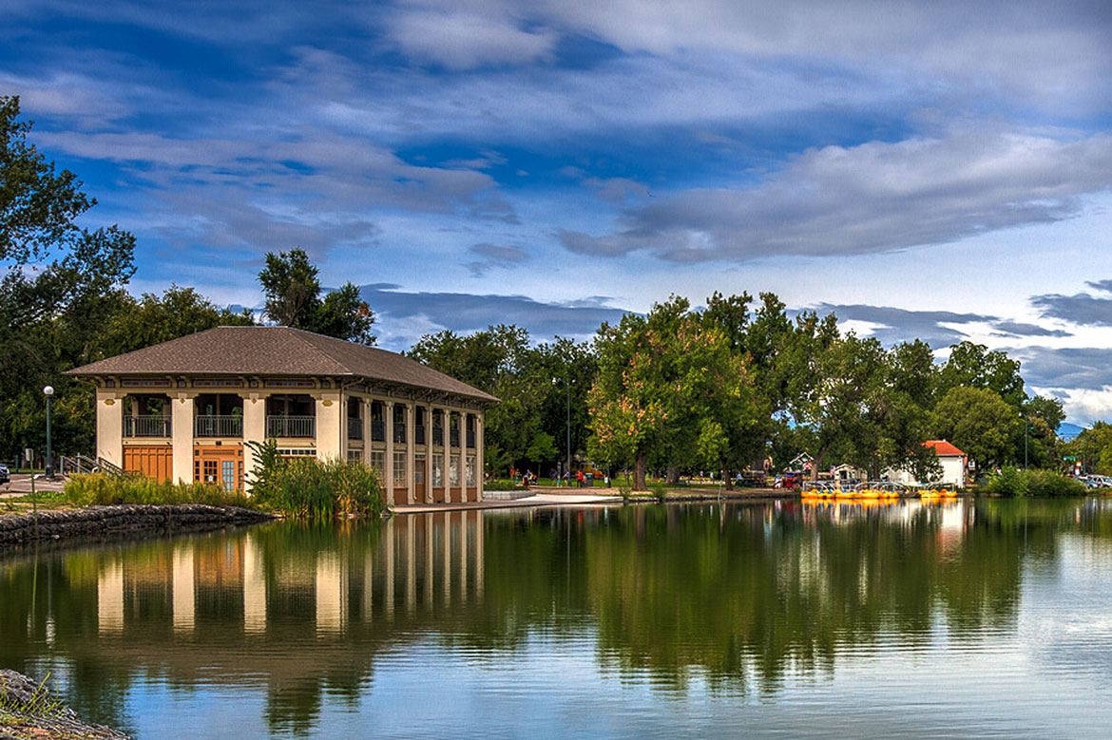

Denver is a beautiful city that is sunny, with gorgeous views of the Rocky Mountains. It has a lot to do in terms of city life as well as being close to the foothills and mountains for biking, walking, skiing, and other outdoor activities.
St. John’s ministry includes an Early Learning Center and a Kindergarten through 8th grade school. Full time staff receive family health insurance and tuition benefits for their children according to the number of years of employment at St. John's/Renewal. The benefits include Before and After School Care, the Early Learning Center and the K-8 School.
If you are interested or know someone that is: please submit a resume to Lead Pastor Andrew Farhat at pastor.andrew@sjdenver.org.

